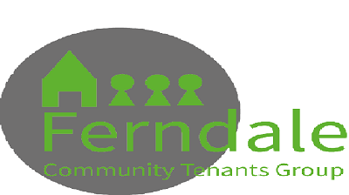
Consent form for the use of photographs and video content
I hereby consent to the use of photographs and/or video content of myself/my child (delete as applicable), for use by Ferndale Community Tenants Group and Clarion Housing Group for the following purpose(s).
Publications included but not limited to: Annual Report, newsletters, promotional leaflets, adverts, website, promotional videos, print media (newspapers and magazines), online media and social media.
Consent for an adult
I consent to my photograph or video content of myself being used

Name (in BLOCK capitals):

Address:

Signature:
Date:
Consent for a child
If the person is aged 16 or under, this form MUST be signed by a parent or appropriate adult.
Full name of child / Children (in BLOCK capitals):
Name of parent/guardian:
Address:

Signature:
Date:

